Math Circle Problem Set 7. Name:

Problem 7.1: You have three jugs of water, with capacities 8 liters, 5 liters, and 3 liters. The 8-liter jug is full while the other two are empty. How can you measure out exactly 4 liters? There are no measurements on the side of the jugs.
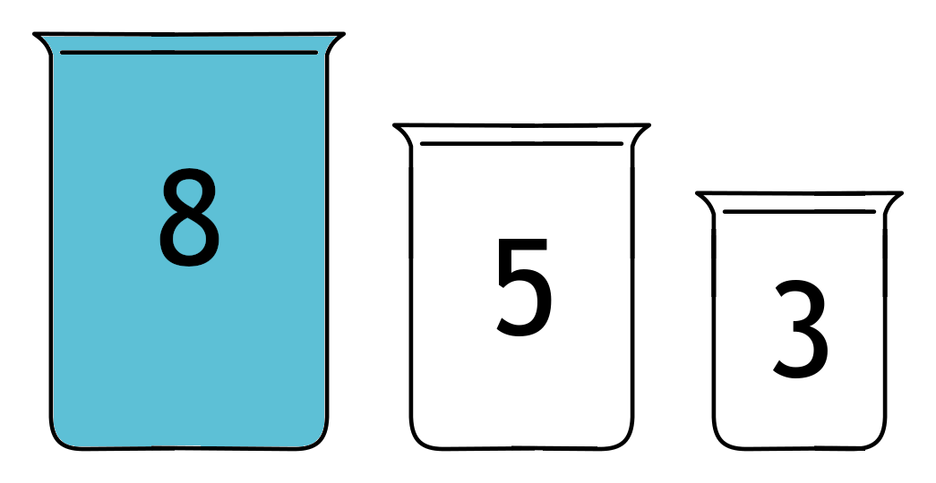

Problem 7.2: A group of 5 children meets, and each pair of children shakes hands. How many handshakes were there total?

Problem 7.3: Now a 6th child joins the group and shakes hands with everyone. How many handshakes does this add? How many handshakes have there been in total?

Problem 7.4: Guess the next number in the sequence: 1, 1, 2, 3, 5, 8, ???.

Problem 7.5: How many ways are there to make a 1x4 board if you can use 1x1 or 1x2 pieces?

Problem 7.6: How many ways are there to make a 1x5 board?

Problem 7.7: Without writing them all out, how could we find the number of ways to make a 1x6 board?

Problem 7.8: Regarding the solitaire card game from last week: if the deck has 10 cards, how can we get 1,2,3,4,5,6,7,8,9,10 as the outcome?

